

**Green University of Bangladesh**

**Department of Computer Science and Engineering (CSE)**

**Faculty of Sciences and Engineering**

**Semester: (Summer, Year:2025), B.Sc. in CSE (Day)**

**LAB REPORT NO: 1**

**Course Title:** Database Lab

**Course Code:** CSE 210 **Section:** 232-D1

**Lab Experiment Name**: Implement different kinds of integrity constraints.

**Student Details**

|  |  |  |
| --- | --- | --- |
| **Name** | | **ID** |
| **1.** | Rukonuzzaman Topu | 232002280 |

**Submission Date : 07-07-2025**

**Course Teacher’s Name :** Farhana Akter Sunny

**[For Teachers use only: Don’t Write Anything inside this box]**

|  |
| --- |
| **Lab Report Status**  **Marks: ………………………………… Signature:.....................**  **Comments:.............................................. Date:..............................** |

1. **TITLE OF THE LAB EXPERIMENT:**

Implement different kinds of integrity constraints.

**OBJECTIVES:**

* Define primary Keys for ensuring unique record identification.
* To establish Composite Keys involving multiple columns for complex uniqueness.
* To apply Unique Constraints for maintaining data uniqueness across columns.
* To enforce Not Null Constraints to prevent the entry of missing values.
* To implement Check Constraints for validating data input and ensuring accuracy.
* To create Foreign Key Constraints to link related tables and ensure consistency.
* To maintain Referential Integrity across related datasets.
* To enhance the consistency and reliability of stored data..

**PROCEDURE:**

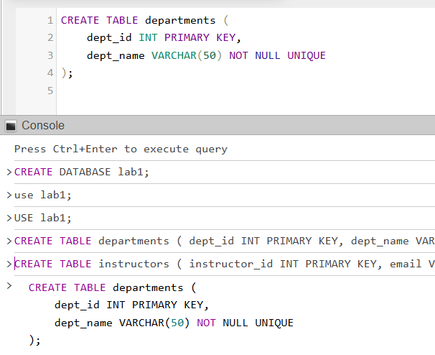

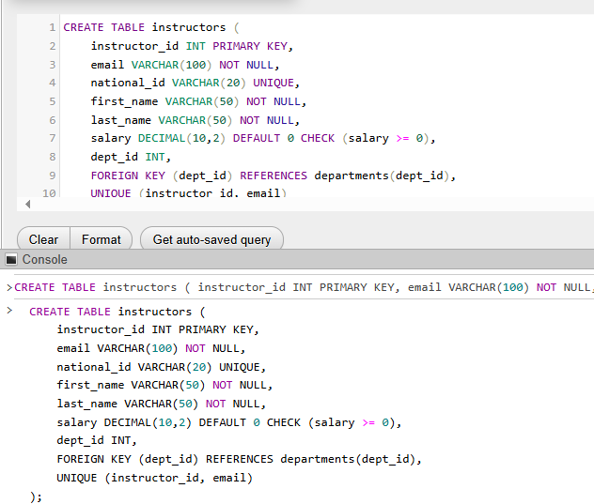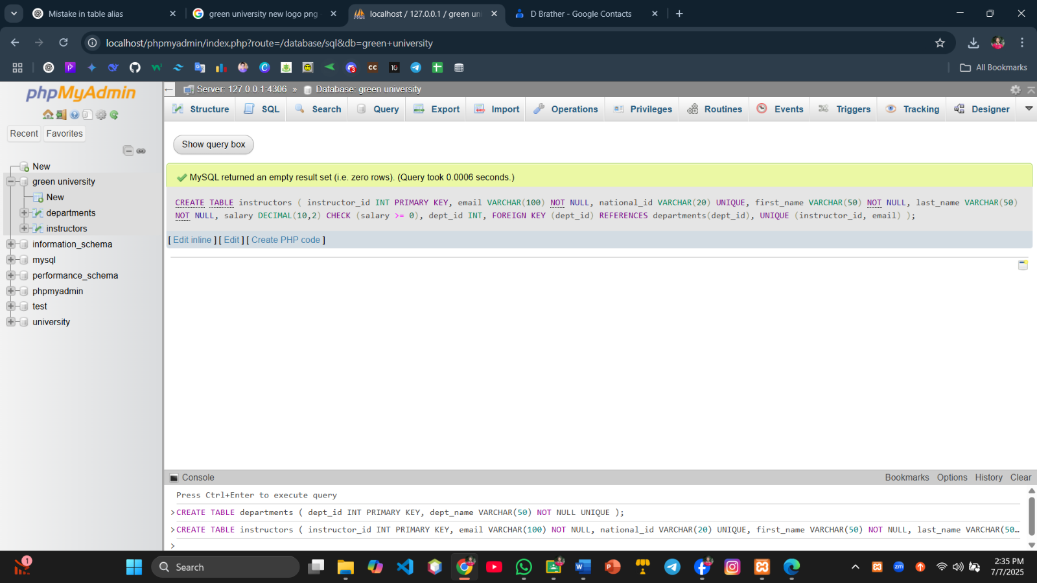

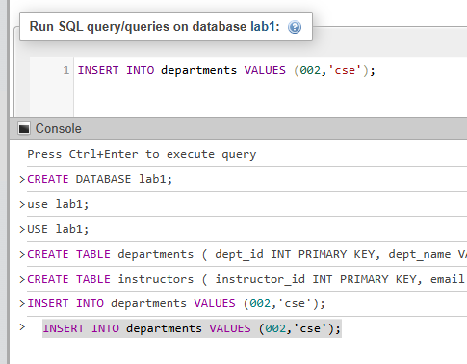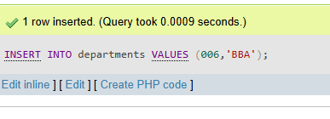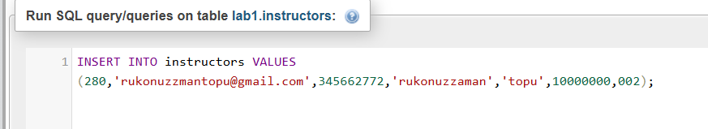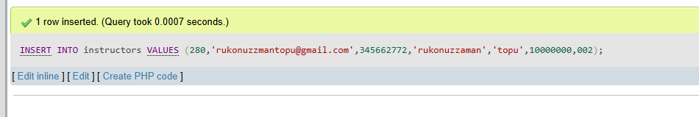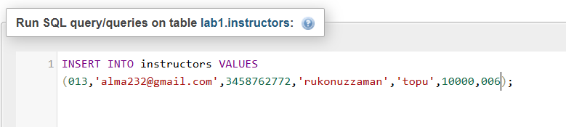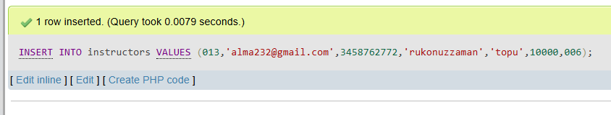

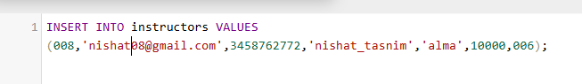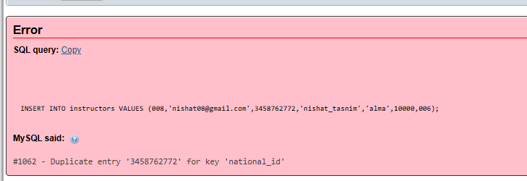

**OUTPUT:**

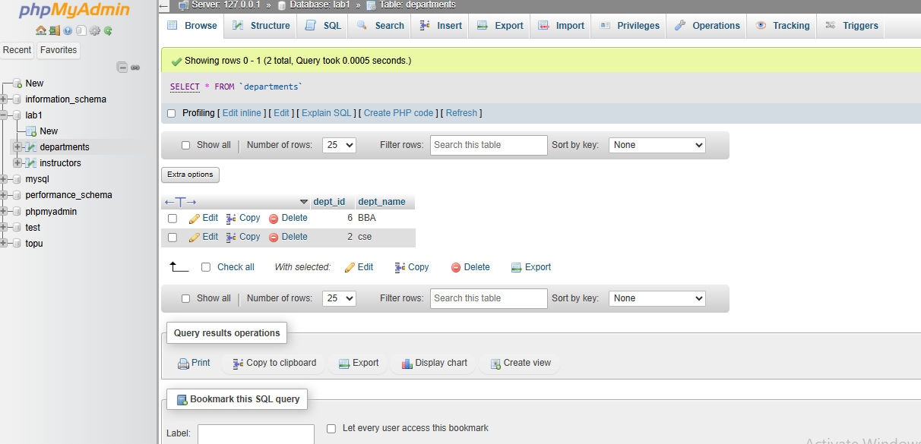

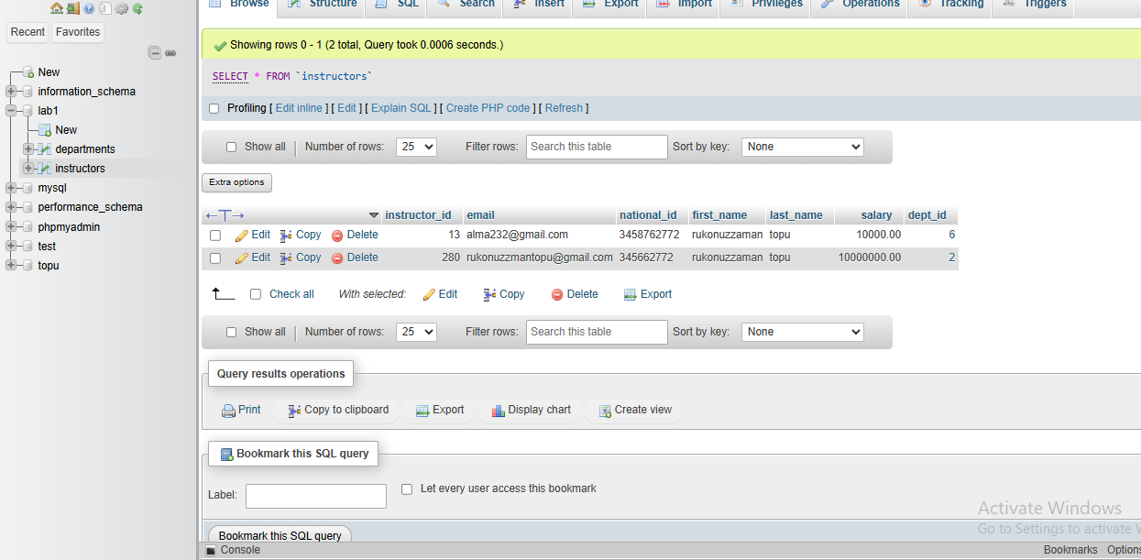

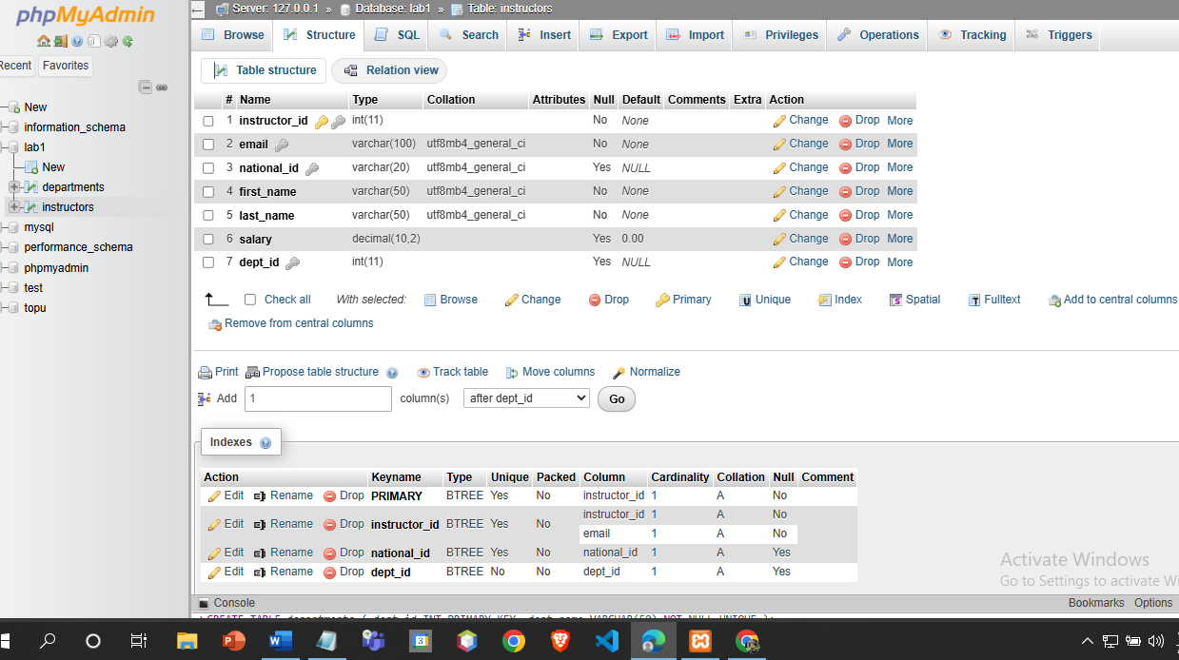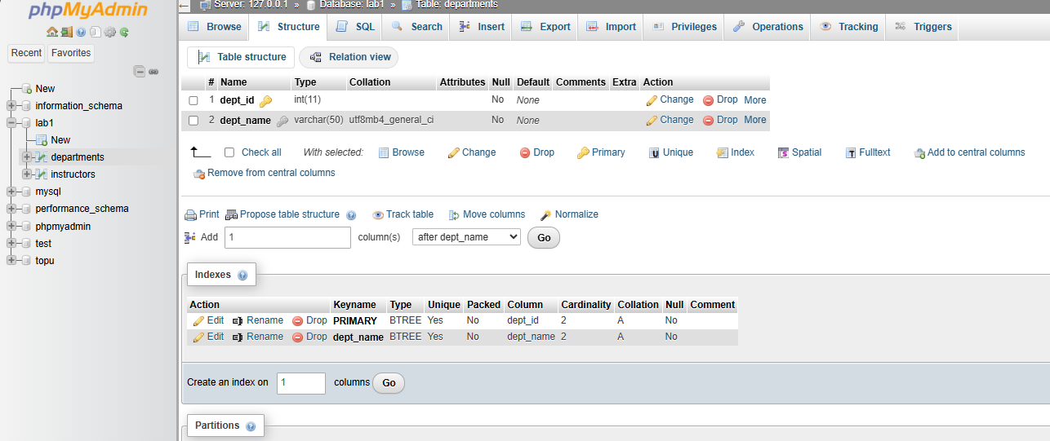

**Discussion:**  
The above SQL implementation showcases how integrity constraints promote data reliability in relational databases. The primary key uniquely identifies each instructor, while the unique and not null constraints ensure consistency and accuracy of the data. The foreign key constraint preserves referential integrity by associating instructors with valid departments. Check constraints ensure that salary values meet logical conditions. Successful data insertion verifies the correctness of the schema design, and errors highlight potential violations, demonstrating the vital role of constraints in preventing invalid data entry.